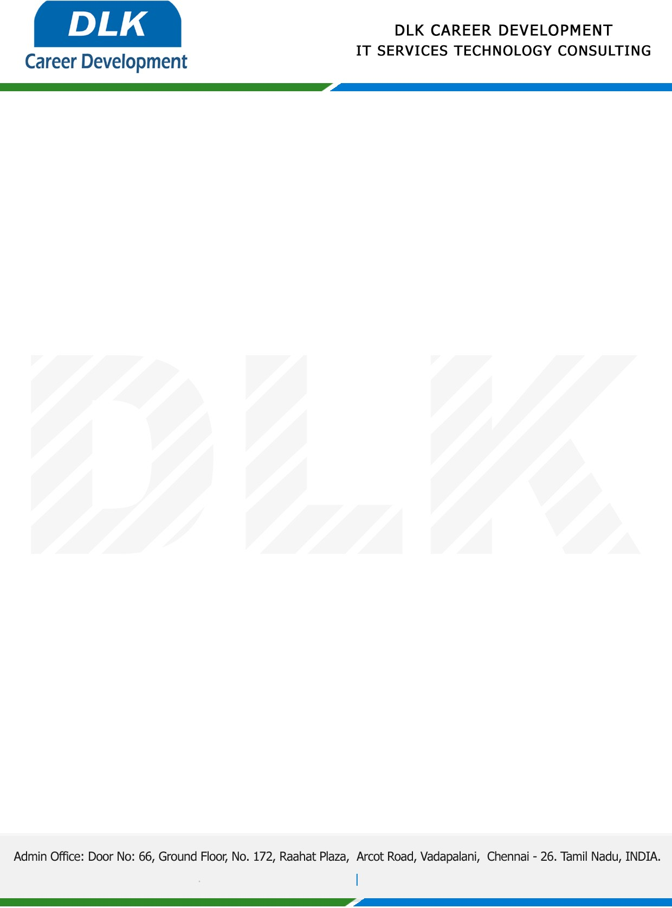

Date: 18 /May / 2023

**To**

Department of B. Tech (Artificial Intelligence and Data Science),

Head of Department,

Builders Engineering College, Erode.

**Sub: Letter of Internship Acceptance**

This is to certify that **MS ABIRAMI M (REG NO:** **730321243001 )** second year student of has accepted the internship Work duration from **20th June 2023** to **10th July 2023** under the domain **“Web Designing & Web Development”.** During the internship, all information and data collected from you should be kept confidential.

We appreciate your interest in **DLK CAREER DEVELOPMENT**

